 The projective plane P2

Introduction

We now come to a geometric structure that is more abstract than the previous two we have dealt with. The geometry of the projective plane will resemble that of the sphere in many respects. However, we regain the Euclidean phenomenon that two lines can intersect only once. The projective plane will also be a foundation for our study of hyperbolic geometry in Chapter 7.

Although many of the properties of the projective plane are familiar, one that will appear strange is that of nonorientability. In P2 every reflection may be regarded as a rotation. This has the intuitive consequence that an outline of a left hand can be moved continuously to coincide with its mirror image, the outline of a right hand.

The abstraction is involved in the fact that every point of P2 is a pair of points of S2 . Two antipodal points of S2 are considered to be the same point Of p2.

Definition. The projective plane P2 is the set of all pairs {x, —x} of antipodal points of S2 .

Remark: Two alternative definitions of P2 , equivalent to the preceding one are

i. The set of all lines through the origin in E3 ii. The set of all equivalence classes of ordered triples (Xl, x2, .x3) of numbers (i.e., vectors in E3) not all zero, where two vectors are equivalent if they are proportional.

Let q: S2 -9 P2 be the mapping that sends each x to {x, —x}. Then is a two-to-one map of S2 onto P2

A line of P2 is a set of the form TTC, where e is a line of S2 . If is a pole of e, then is called the pole of TTC. Clearly, lies on if and only if 1 24 (E, x) = 0. Two points are perpendicular if their representatives on S2 are perpendicular. Two lines are perpendicular if their poles are perpendicu- Homogeneous coordinates lar.

# Incidence properties of P2

Theorem 1.

i. Two lines of P2 have exactly one point of intersection. ii. Two points of P2 lie on exactly one line.

Proof:

1. Let and be poles of lines of P2 . Because * ITT), and are not antipodal. Thus, x and —E x determine the two points of intersection of the. corresponding lines of S2 (Theorem 4.7). But x n) and x n) are the same point of P2 .
2. Again, let TX and TTY be points of P2 . Then X and Y are not antipodal, so they lie on a unique line e of S2 (Theorem 4.6). Thus, TX and TTY lie on TTC.

# Homogeneous coordinates

Let {el, e2, e3} be a basis of R3 . Then every vector x e R3 determines a unique triple (Xl, x2, x3) of real numbers according to the equation

X = Xlel + X2e2 + X3%.

If is a point of P2 , k is any nonzero real number, and

k X = + 1.8-82 + 1.13%,

then (ul, u2, u3) is called a homogeneous coordinate vector of TX. We say that ul, u-z, are homogeneous coordinates of TX.

Let = (El, E2, Q) and x = (Xl, x2, xo. Then (E, x) = O becomes the equation of the line with pole TTE. Homogeneous coordinates are often a useful computational device. Their usefulness is primarily due to the following result.

Theorem 2. Let P, Q, R, and S be four points ofP2 , no three of which are collinear. Then there is a basis of R3 with respect to which the four points have coordinates (1, O, O), (0, 1, 0), (0, 0, 1), and (1, 1, 1).

Proof: Let VI, v2, and be any vectors in R3 that are representatives of P, Q, and R, respectively. Because P, Q, and R are not collinear, these three vectors are linearly independent. Let be any representative of S. Now there must exist real numbers kl, k2, k3, none of which is zero, such that

# P2

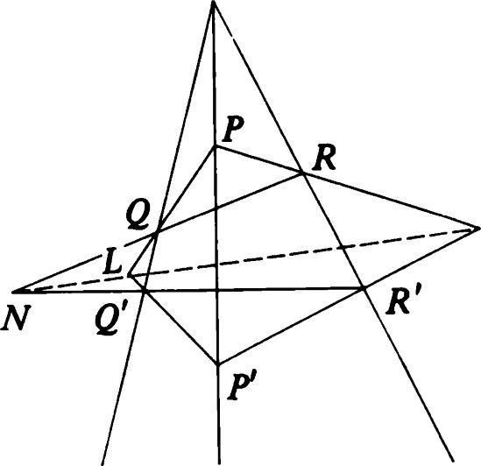M

Figure S.l Desargues' theorem.

 = klt'l + k2V2 + k3V3.

Put el —- klVl, e2 = k2V2, and e3 = k3V3. Then {el, e2, e3} is the required basis.

Theorem 3. Let x and y be homogeneous coordinate vectors of two points ofP2 . Then Rx + py (k, p, real) is a typical point on the line they determine.

## Two famous theorems

Having introduced the incidence structure of P2 and having defined the notion of homogeneous coordinates, we turn to two fundamental classical theorems in projective geometry: Desargues' theorem and Pappus' theorem. The elegance of the statements testifies to the unifying power of proJective geometry. Analogous results in E2 would have to make allowances for many special cases. The elegance of the proofs (which follow Coxeter [71) testifies to the power of the method of homogeneous coordinates. In this section the word "triangle" denotes a set of three noncollinear points. We have not yet defined segrnents in P2 , so our old notion of triangle does not apply.

Theorem 4 (Desargues' theorem . Let PQR and P'Q'R' be triangles in P2 . Suppose PP', QQ', and R ' are concurrent. Then PQ n P' Q',

QR n Q'R', and PR n P'R' are collinear. (See Figure 5.1.)

Proof: We may choose a basis for R3 such that in the associated homogeneous coordinate system P = (1, O, O), Q = (O, 1, O), R = (O, O, 1), and X = (1, 1, 1), where X is the given point of concurrence. If X were collinear with any two of these points, then two sides (such as PQ and P'Q') would coincide, leaving the conclusion meaningless. Thus, we may assume that no three of P, Q, R, and X are collinear. Now P' may be given coordinates (p, 1, 1) because



which is equivalent to

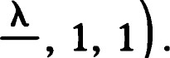

l)

Similarly, Q' = (1, q, 1) and R r). Now the equation of PQ is = O, and that of P'Q' is

(1 — q)X1 + (1 — p)X2 + (pq - 1)x3

These lines intersect in L = (p — 1, 1 — q, O). Similarly, the other two points of intersection are M = (1 — p, 0, r - 1) and N = (0, q - 1, 1 The three points L, M, and N are collinear because the sum of the three coordinate vectors is zero.

Theorem 5 (Pappus' theorem). Let AIBICI and A2B2C2 be collinear triples of points. Then the points AIB2 n A2B1 = G, B2C1 n BIC2 = 143, and

AIC2 n A2C1 = B3 are collinear. (See Figure 5.2.)

Proof: Assign homogeneous coordinates as follows:







Then

 = BIA3 n B3Al = (pq, q, 1),  = AlB2 n A2Bl = (pr, 1, r).

Because A2, B2, and C2 are collinear, we must have



On the other hand,

 = (pq, q, 1 ) = (pqr, qr, r).

Thus, we must have pqr

Applications to E2

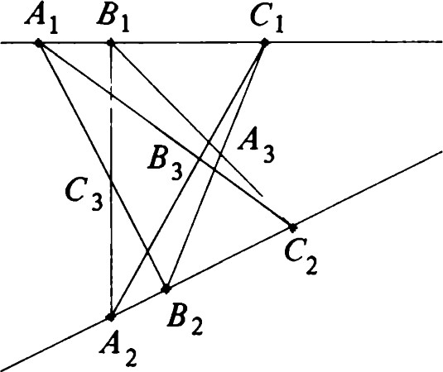

2

|  |
| --- |
| Now A3B3 consists of points of the form (O, O, k) + (1, q, 1)  (1, q, 1 + k). Because G = (pqr, q, rq) = (1, q, rq), it must be on this line.  Applications to E2  One of the reasons for the invention of P2 was to simplify the incidence geometry of E2 . To illustrate this, consider the following picture in E3 . We regard the plane x3 = 1 consisting of all points in E3 of the form (Xl, x2, 1) as a model of E2 . Every line through the origin of E3 that is not parallel to E2 meets E2 in a unique point. If (Xl, x2, x3) are homogeneous coordinates for such a point of P2 , then  (5.1) |

Figure 5.2 Pappus' theorem.

P?

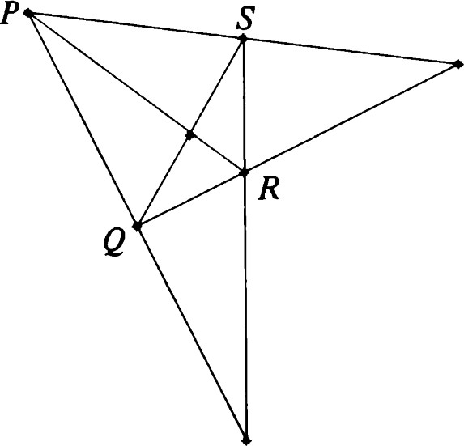

Figure 5.3 Quadrangle: Case 1.

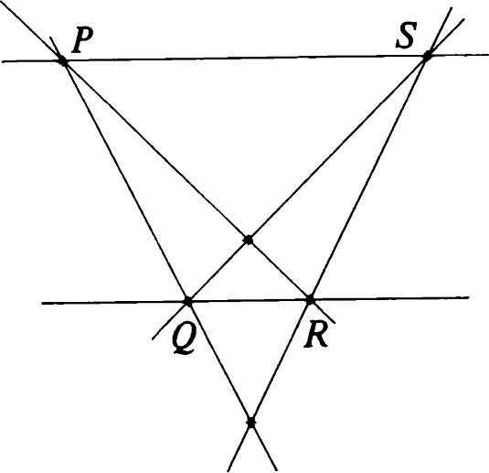

Figure 5.4 Quadrangle: Case 2.

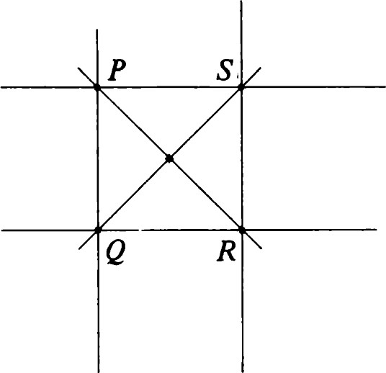

Figure 5.5 Quadrangle: Case 3.

is the corresponding point of E2. Conversely, each point of E2 determines a unique point of P2

Every line of E2 determines a unique plane through the origin in E3 and, hence, a unique line of P2 . Every line of P2 determines a unique plane through the origin in E3 and, hence (with one exception), a unique line of E2 . The exception is the plane through the origin parallel to E2 . Let T: E2 -+ P2 be the map we have been discussing.

Theorem 6.

1. Denote by the exceptional line ofP2 . Then T maps E2 bijectively to



1. Let P and Q be points ofE2 . Then TP and TQ determine a line C' ofP2 , and T maps e = PQ bijectively to C' iii. Let e be lines ofE2 . Ife n m = P, then e' n m' = TP. oc e Il m, then C' n m' lies on eæ.

Remark: What this theorem says is that P2 contains a subset that has the same incidence structure as E2 . Two lines will be parallel on E2 if and only if they correspond to lines meeting on em.

Example: A quadrangle PQRS in P2 consists of four points, no three collinear, and the six lines drawn through pairs of vertices. The three points PQ n RS, PR n QS, and PS n QR are called diagonal points of the quadrangle. Now the corresponding figure in E2 can take on many forms, depending on where intersects the figure. We list the possibilities. They are illustrated in Figures 5.3—5.7.

1. contains no vertex (P, Q, R, or S) and no diagonal point. In this case we have an ordinary Euclidean quadrangle.
2. contains no vertex but one diagonal point. In this case two sides of the quadrangle are parallel; the other two are not.
3. contains no vertex but two diagonal points. In this case we have a parallelogram.
4. contains one vertex and no diagonal points. Here we have three ordinary points Q, R, and S, the lines QR and RS, together with parallel lines through Q and S, respectively.
5. contains two vertices P and Q. In this case one diagonal point is forced to be on eco.

|  |
| --- |
| gets farther and farther away in E2 . On P2 the corresponding point is getting closer to em. This is why is sometimes called "the line at 00.' This also accounts for the statement "parallel lines meet at 00.' |

If we start with the general case (1) and gradually turn one of the lines, say PS, while leaving the others fixed, the point of intersection PS n QR

## Desargues' theorem in E2

The projective version of Desargues' theorem has many interpretations in E2 , depending on where the various lines cut coo. For instance, if X is on coo, the theorem would read as follows.

Theorem 7. Let PQR and P'Q'R' be triangles in E2 . Suppose that PP', QQ', and RR' are parallel. Then

1. IfPQ Il P'Q' and QR Il Q'R', then PR Il P'R' (Figure 5.8).
2. IfPQ Il P'Q' but QR n Q'R' = N, then PR and P'R' meet (say in M), and MN is parallel to PQ (Figure 5.9).
3. IfPQ n P'Q' = L, QR n Q'R' = M and PR n P'R' = N, then L, M, and N are collinear (Figure 5.10).

Observe that the three cases correspond to the following in P2 .

i. contains all three of L, M, and N. ii. contains one of L, M, or N.

iii. contains none of L, M, or N.

If X is not on in Desargues' theorem, it would read as follows.

Theorem 8. Let PQR and P'Q' R' be triangles in E2 . Suppose PP', QQ' and RR' meet in X. Then the conclusions of Theorem 7 hold.

If we take to be the line PP'X in Desargues' theorem, we get the following:

Theorem 9. Let QRR'Q' be a trapezoid (QQ'IIRR'). Let e and m be parallel lines through Q and R. Let C' and m' be parallel lines through Q'

The projective group

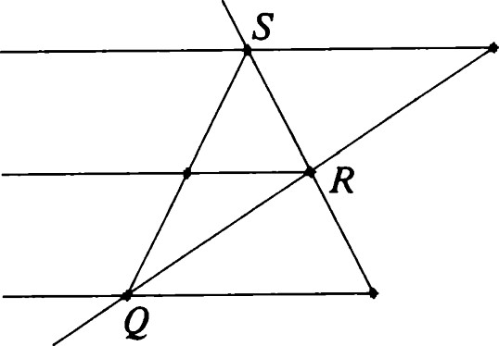

Figure 5.6 Quadrangle: Case 4.

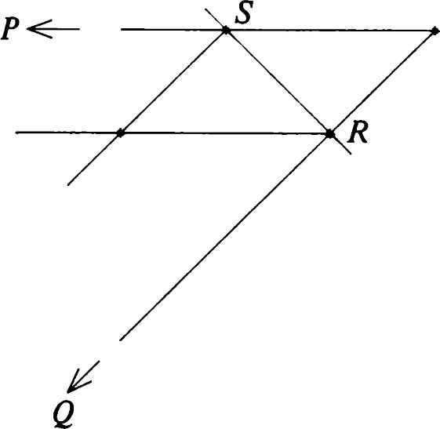

Figure 5.7 Quadrangle: Case 5.

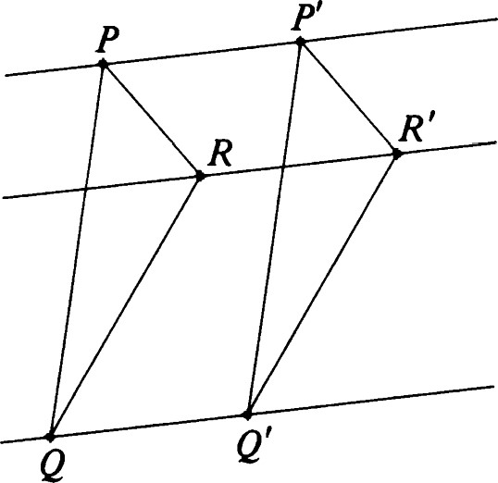and R'. LetX= e n C', n m', and Z = QR n Q'R'. Then X, Y, and Z are collinear.

Theorem 10. Let QRR'Q' be a parallelogram in E2 (QQ'IIRR' and Q' R' IIQR). Let e and m be parallel lines through Q and R. Let C' and m' be parallel lines through Q' and R'. If X = e n e ' and Y = m n m', then XY is parallel to QR.

The projective group Figure 5.8 Affine consequences of Desargues' theorem: Case 1.

Let PGL(2) be the group of collineations of P2 . (Use the same definition as for E2 .) Each invertible linear map A: R3 -+ R3 determines a unique collineation Ä in PGL(2) according to the definition

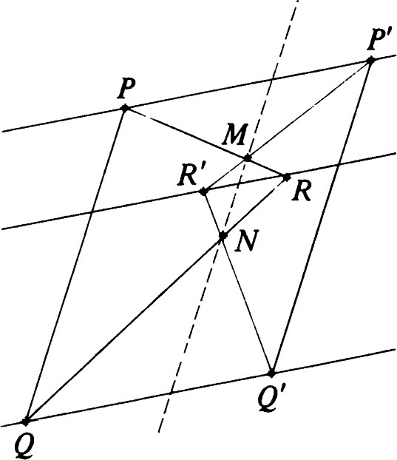

Figure 5.9 Affine consequences of Desargues' theorem: Case 2.

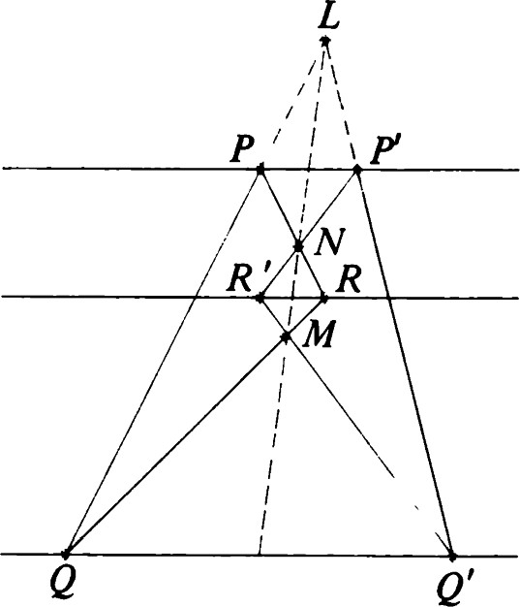

Figure 5.10 Affine consequences of Desargues' theorem: Case 3.

Äqx = TAX. (5.2)

The mapping A —+ Ä is a homomorphism of GL(3) -4 PGL(2) whose kernel is

K = {kllk R}.

It is a fact that this map is surjective (Exercise 17), so that

PGL(2).

This fact is equivalent to the characterization of affine transformations in Theorem 2.2, whose proof is given in Appendix E.

Now if A = kl, then detA = V. Because = 1 if and only if k = 1, we see that

1. Every member of GL(3) is equivalent to (is a multiple of) some member of SL(3). In particular, if k = (detA) 1/3 , we see that det(kA) = 1, so that kA SL(3).
2. SL(3) n K = {1}.

Thus, the homomorphism restricted to SL(3) is an isomorphism, and SL(3) PGL(2).

The subgroup of PGL(2) that fixes may be identified with AF(2). In fact, it is the image of AF(2) under the composition of the usual mappings:

AF(2) -+ GL(3) -9 PGL(2). (5.3)

It is easy to check that this composite mapping is injective.

An element of PGL(2) is called a projective collineation or projective transformation.

## The fundamental theorem of projective geometry

Theorem 11. Let PQRS and P'Q'R'S' be quadrangles. Then there is a unique T PGL(2) such that TP = P', TQ = Q', TR = R', and TS = S'.

Proof: Choose homogeneous coordinates of (1, 0, 0), (0, 1, O), (O, 0, 1), and (1, 1, 1) for P, Q, R, and S, respectively. Then let A be a matrix whose columns are coordinate vectors for P', Q', and R' respectively. Call them x, y, and z. Now

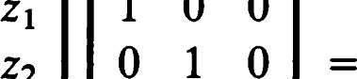

1

o

o

1

 O o 1

However, A survey of projective

collineations

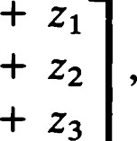  1+ Yl

 1+ Y2

 1+ Y3

|  |  |  |
| --- | --- | --- |
| and, for any X, p, v, |  |  |
| X Xl pyl VZI | 1 | k Xl + I.LYI + VZI |

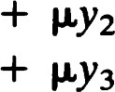xx2 1•LY2 vz2 1+ VZ2 VZ3 1 + VZ3

|  |  |
| --- | --- |
| Choose k, p, and v so that  w — Xx + py + vz  is a coordinate vector for S'. The projective collineation whose matrix with respect to P, Q, R, and S is  X.XI pyl VZI  x.X2 1.LY2  x.x3 p.).'3 vz3  is the required transformation T. Uniqueness will be proved in Exercise 16.  Corollary. Let {P, Q, R} and {P', Q', R'} be two noncollinear triples of points. Let e be a line not containing any of these points. Then there is a unique projective collineation Tsuch that TP = P', TQ = Q', TR = R', and  Proof: Let PQ and P'Q' meet e in A and A', respectively. Let PR and P'R' meet e in B and B', respectively. Then RQAB and R'Q'A'B' are quadrangles to which the fundamental theorem may be applied. The unique T so determined leaves e fixed. Furthermore, because P = RB n QA, TP must be R'B' n Q'A' = P'.  Conversely, any projective collineation satisfying the stated conditions must take A to A' and B to B' and so must coincide with T.  Remark: When a choice of has been made, this corollary with e = is just the fundamental theorem of affine geometry (Theorem 2.8).  A survey of projective collineations  In this section we will outline some of the facts about projective collineations. This material would occupy a whole chapter if done in detail. | 1 31 |

Because our main emphasis in this book is on metric geometry, we will present the results with a minimum of discussion. All the necessary background for proving the theorems as exercises has already been developed.

Theorem 12. Every projective collineation has at least one fixed point and one fixed line.

In view of Theorem 12 it is useful to choose a point P and a line e and examine the group of all projective collineations, leaving them fixed. We choose a homogeneous coordinate system in which P and e have simple representations. If P lies on e, let P = (1, 0, O). If P does not lie on e, take P = (0, O, 1). In either case we can arrange that e has the equation x3 = 0. The next few theorems assume a homogeneous coordinate system satisfying these conditions.

Theorem 13. If P does not lie on e, the group of projective collineations leaving P and e fixed is isomorphic to GL(2). Each such collineation can be uniquely written in the form



# 0 0 1

Theorem 14. Suppose that P lies on e. Then every projective collineation leaving P and e fixed is uniquely represented by a matrix of the form

# 0 0 1

Conversely, each such matrix determines a projective collineation leaving P and e fixed.

Taking e -— allows us to regard this group as the group of affine transformations leaving fixed one particular pencil of parallels, namely, the lines parallel to the xraxis. In fact, if two points (k, p) and (i, p) in E2 have the same xycoordinate, then

# 0 0 1 1 1

so that their images also have the same xycoordinate. In affine terms this transformation is a central dilatation (centered at the origin), followed by a shear, and then a translation.

Of course, the transformation of Theorem 14 may have fixed points other than P and/or fixed lines other than e. In fact,

Theorem 15. The transformation of Theorem 14 has exactly one fixed point and one fixed line if and only if a = 1 and bq * 0.

Theorem 16. A projective collineation with two fixed points may be written in the form

# 0 0 1

Such a collineation has at least two fixed lines.

Corollary. A projective collineation with two fixed points may be written in the form

# 0 0 1

In this representation (1, O, O) and (O, 1, O) are fixed points. The lines = 0 and x3 = O are fixed lines.

Theorem 17. If a projective collineation has three collinear fixed points, it may be written

# 0 0 1

Every point on the line = O is fixed. In addition, the line .x3 = O is a fixed line.

The transformations of Theorem 17 are called perspective collineations. A perspective collineation with axis e and center P is a projective collineation that leaves fixed every point on e and every line through P. We may regard the identity as the trivial perspective collineation. All other perspective collineations have a unique axis and a unique center. A nontrivial perspective collineation is called an elation if its axis and center are incident; otherwise, it is called a homology.

Theorem 18. When a perspective collineation is represented as in Theorem

17, it is

i. an elation if a = 1 and q * 0;

A survey of projective collineations

ii. the identity if a = 1 and q = O; iii. a homology if a * 1.

Remark. If is taken to be the axis of a perspective collineation, elations become translations and homologies become central dilatations. On the other hand, if is one of the other fixed lines, elations become shears and homologies become stretches along one direction (see Theorem 2.20, case (iv)) possibly composed with an affine reflection. The special homology giving rise to an affine reflection is called a harmonic homology.

The term "perspective collineation" is explained by the following theorem.

Theorem 19, Suppose that a nontrivial perspective collineation with center P takes X to X'. Then P, X, and X' are collinear.

Theorem 20. Let P be a point and e a line. Let X and X' be points collinear with P. Assume that X and X' are not on e and not equal to P. Then there is a unique perspective collineation with center P and axis e that takes X to X'.

## Polarities

Let b be a real-valued, symmetric, nondegenerate, bilinear function on E3 . If {el, e2, e3} is a basis for R3 . we have

3

b(x, y) = Xiyjb@i, 0.)

3

- bijXiYj = xtBy = (x, By), (5.4)

where B = [b ij ] = [b(ei, ej)]•

Each such b determines a relation



consisting of those pairs (TX, try) such that b(x, y) = O.

The relation b is called a polarity. If b(x, y) = O, we say that and ny are conjugate. For a given y the set

{qxlb(x, y) = O}

is a line called the polar line of Try. We call ny the pole of the line with respect to b.

Some polarities have self-conjugate points. The set of self-conjugate Polarities points is called a conic determined by the polarity. For example, if

## 0 1

then the conic determined by b is

{nxlxtBx = O} = {qxlx} + x2 — x3

This conic in P2 corresponds by formula (5.1) to the unit circle x} + x2 in E2 .

Similarly,

O gives the ellipse 2x} + 3x2

### -2 o O

O 3 O gives the hyperbola —2K} + 3x;

o 1 o gives the parabola x2 = 4XI•

—2 O o

Some polarities do not have self-conjugate points. For example, if

# 1 0 0

0 1 0 0 0 1 then

b (x , y) = X IYI + X2Y2 + X3Y3

and b(x, y) = O if and only if x} + x; + x; = O. The fact the b has no self-conjugate points translates to the fact that no line can be perpendicular to itself in E3 .

A polarity also induces a relation among the lines of P2 . Two lines are said to be conjugate if the pole of one lies on the other. A line that passes through its own pole is said to be self-conjugate.

Theorem 21. Let P and Q be points ofP2 with respective polar lines' and

q. Then P lies on q if and only if Q lies on h.

Proof: Let P = and Q = try. Then P lies on q if and only if b(x, y) = O. By symmetry this is also the condition for Q to lie on'.

Theorem 22. Let P and Q be self-conjugate points ofP2 . Then PQ cannot be a self-conjugate line.

Proof: Let and q be the respective polar lines of P and Q. The lines and are distinct because P and Q are distinct. Let R be the point where' and q intersect. This point is not on PQ. Because R is conjugate to both P and Q, its polar line must pass through both P and Q; that is, a = PQ. The line a is not self-conjugate because it does not pass through R.

Theorem 23. A line contains exactly one self-conjugate point if and only if it is a self-conjugate line.

Proof: Let e be a line with exactly one self-conjugate point P = ax. Let Q = ny be any other point of e. Then for any real number X,

b(x + Xy, x + Xy) = b(x, x) + 2kb(x, y) + X2b(y, y)

= y) + kb(y, y)).

Because there is only one self-conjugate point on e, we must have b(x, y) = O. Otherwise, one could solve the equation for a nonzero value of X. Because the equation b(x, y) = O holds for all x with on e, the pole of e is Hence, e is a self-conjugate line.

Conversely, if a line is self-conjugate, its pole is self-conjugate. By Theorem 22 the line can have no other self-conjugate points.

Definition. Let b be a polarity defining a conic C. A line that is selfconjuga!e with respect to b is called a tangent to the conic g. The pole of this line is called the point of contact. (See Figure 5.11 in which e and are tangents having respective points of contact L and M.)

Corollary. A line meets a conic in at most two points.

Proof: This follows from considering a quadratic function of the type occurring in Theorem 23.

Definition. A line that meets a conic twice is called a secant.

## Cross products

Conjugacy with respect to a polarity is a generalization of the theory of perpendicularity with respect to an inner product. We recall that in order to find a vector in E3 that is perpendicular to two given vectors, we

1 36 construct the cross product.

If u and v are vectors in R3 , there is a unique vector w in R3 such that, Cross products for all z e R3 ,

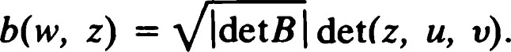

Here we may compute the right side by writing z, u, and v as column vectors and taking the determinant of the resulting 3 x 3 matrix.

We call w the cross product (of u and v) with respect to b and write w = u x bV or simply w = u x v if b is clear from the context.

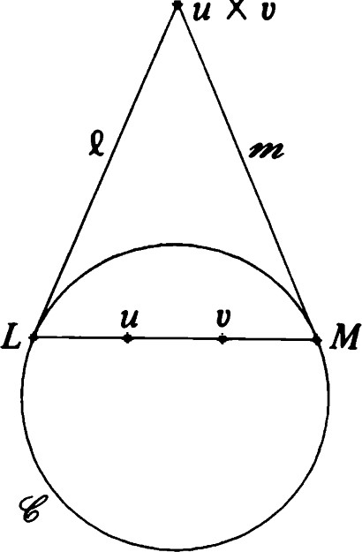

u

Xv

Clearly, the formulas b(u x v, w) = b(u, v x w)

and

b(u, u x v) = b(v, u x v) = O

are true. Thus the cross product is a device for computing poles of lines. The following proposition is obvious.

Theorem 24. Let nu and be points in P2 . Then the line joining qu and has pole qr(u x v). (Again see Figure 5.11.) Figure 5.11 Conic; tangents, pole, and polar. Definition A triangle APQR ofP2 is said to be self-polar if each vertex is the pole of the side opposite it. Any self-polar triangle gives rise to a basis {el, e2, e3} ofR3 such that b(ei, ej) = O for i j and b(ei, q) = ± 1. Such a basis is said to be orthonormal with respect to b.

Theorem 25.

1. Let {el, e2, e3} be orthonormal with respect to b. Then, after replacing e3 by its negative if necessary, we have

el X e2 = b(e3, e3)e3,

 = b(el, el)el,

X el e2)e2.

1. For a given b the number of occurrences of —1 among the b(ei, q) is independent of the choice of orthonormal basis.

Definition.Let b be a nondegenerate, bilinear, symmetric function. Suppose that {q} is a basis orthonormal with respect to b. Suppose that +1 occurs r times and —1 occurs s times among the b(ei, q). Then the ordered pair (r, s) is called the signature of b.

The following (vector triple product) formula is indispensable for computation.

Theorem 26. (u x v) x w = (—1)S (b(u, w)v — b(v, w)u), where the signature of b is (r, s).

Proof: Choose a basis of the type used in Theorem 25. Then

(el x e2) x e2 = b @3, e3)e3 x e2 = —b(e3, el)el, e2)e2 — b(e2, e2)e1) =  e2)e1.

These are equal if and only if b(el, e3)

that is, b(el,



e3)

The other combinations can be checked similarly.

## EXERCISES

1. Prove Theorem 3.
2. Letx = (1, O, 0), y = (1, 1, 0), z = (1, O, 1), w = (1, 1, 1). Let e be the line joining and Try, and let m be the line joining and The'. Find
3. Draw diagrams illustrating the various possibilities in Theorem 8.
4. Draw a diagram illustrating Theorem 9.
5. Draw a diagram illustrating Theorem 10.
6. Pappus' theorem yields many distinct results in E2 depending on the position of em. State as many of these results as you can.
7. Let e and C' be distinct lines, and let C be a point not on either line. The perspectivity [C; e C'] is the mapping a that sends each point P e e to the intersection of PC with C'.
   1. Verify that the mapping is well-defined.
   2. Verify that a is a bijection with exactly one fixed point. iii. Verify that a -I is a perspectivity.
   3. Show that the composition of two perspectivities need not be a perspectivity.
   4. Given four distinct points P, Q, P' , and Q' , prove that there is a unique perspectivity taking P to P' and Q to Q'
8. A projectivity is a composition of finitely many perspectivities. Each projectivity relates a pair of (not necessarily distinct) lines. For each line e prove that the set of all projectivities that take e to itself is a group. With respect to an appropriate choice of homogeneous

1 38 coordinates, find a matrix representation for this group.

|  |  |  |
| --- | --- | --- |
| 9. | Let P, Q, and R be distinct points on a line e, and let P', Q', and R' be distinct points on a line C'. Prove that there is a unique projectivity sending P to P', Q to Q', and R to R'. | Cross products |
| 10. | If e and C' are distinct in Exercise 9, show that the required projectivity may be expressed as the product of two perspectivities. |  |
| 11. | Show that any projectivity is the product of three or fewer perspectivities. |  |
| 12. | Let A, B, C, and D be four collinear points. Show that there is a unique projectivity that interchanges A and B and also interchanges C and D. |  |
| 13. | Show that a projectivity relating distinct lines is a perspectivity if and only if it has a fixed point. |  |
| 14. | Classify the projectivities of a given line e in terms of their fixed point behavior. |  |
| 15. | Prove that a projective collineation that leaves fixed four points, no three of which are collinear, must be the identity. (Hint: Choose to be one of the fixed lines, and apply Theorem 2.2 to P2 — em.) |  |
| 16. | Prove the uniqueness part of Theorem 11 — there is only one projective collineation relating two specified quadrangles. |  |
| 17. | Prove that every projective collineation is of the form Ä for some A e GL(3). |  |
| 18. | The fixed lines of a projective collineation Ä can be found by computing the eigenvectors of A t. Justify this statement and use it to prove Theorem 12. |  |
| 19. | Prove Theorem 13. |  |
| 20. | If T is a projective collineation, prove that the restriction of T to one line e is a projectivity. Prove also that every projectivity arises in this way. |  |
| 21. | Prove Theorem 14. |  |
| 22. | Show that the transformation of Theorem 14 preserves the relationships (a — I)XI + = O and (c — 1)x2 + qx3 = O, in addition to preserving the line x3 — O. Thus, unless a = 1, there is an additional fixed line. Use this to prove Theorem 15. |  |
| 23. | Prove Theorem 16 and its corollary. |  |
| 24. | Prove Theorem 17. |  |
| 25. | Prove Theorem 18. |  |
| 26. | A perspective collineation induces a projectivity on any fixed line. Discuss the fixed point behavior of such a projectivity. |  |
| 27. | Show that the set of perspective collineations with a given axis and | 1 39 |

center (with the identity thrown in) is a group. Do these groups have any finite subgroups?

1. i. Verify the remarks following Theorem 18.
   1. Show that the harmonic homologies are those having a and q = O in Theorem 18.
   2. Prove that the only projective collineations that are involutions are the harmonic homologies.
2. When is taken to be the axis of a harmonic homology, what affine transformation of P2 — results?
3. i. Prove that there is a unique harmonic homology with a given center and axis.
   1. If a is a harmonic homology with center P and axis e and ß is a harmonic homology with center Q and axis m, prove that aß = ßa if and only if Q lies on e and P lies on M.
4. Prove Theorem 19.
5. Prove Theorem 20.
6. Let b be a polarity, and let e be a non-self-conjugate line. For each X e e, let a(X) be the point where the polar line of X intersects e. Prove that a is a projectivity. Show further that a2 = I; that is, a is an involution.
7. Prove Theorem 23.
8. Prove Theorem 25.

### 1 40